**Excercise 1: Setting Up Junit**

1. Create a new Java project in your IDE(intellij IDEA)

* Begin by launching IntelliJ IDEA. We created a Maven-based Java project In IntelliJ, this can be done by clicking File > New > Project, choosing Java, and specifying the project name and location.

1. Add JUnit dependency to your project

* JUnit is added as a test dependency in the pom.xml file of a Maven project.

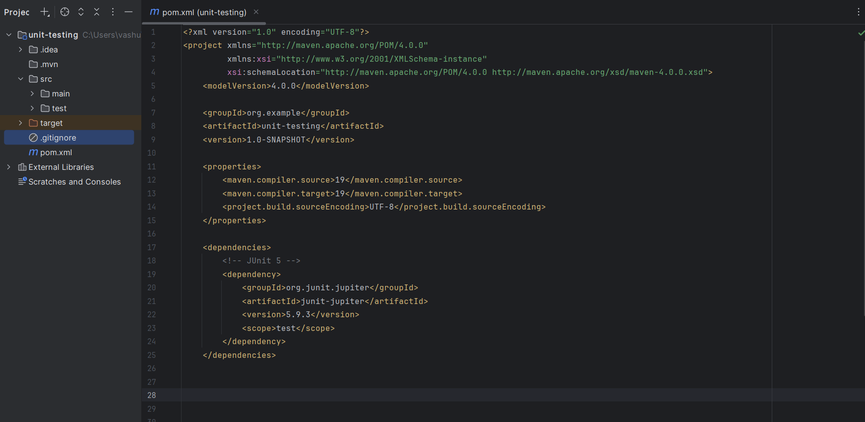

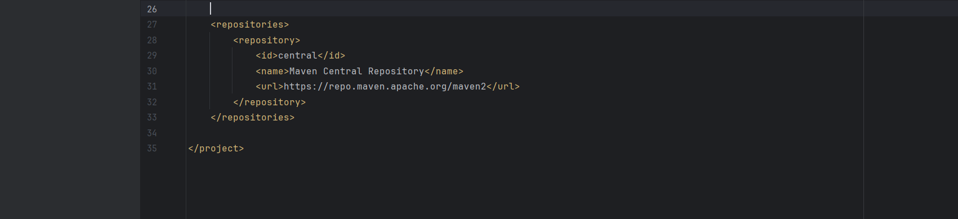

1. Create a new test class in your project

* Created a test class in src/test/java. Used @Test to mark a test method.

